# Asset Alley Landing Page Widget

|  |  |  |
| --- | --- | --- |
| Version | Date | Comment |
| 03 | 01/04/2025 | Added industry type |
| 02 | 27/03/2025 | Improved clarity |
| 01 | 24/03/2025 | Release Version |

### Overview

This application will integrate the Asset Alley landing page for financing website and app development. The code provides options to match the colours of the landing page with your own theme.

### Colour Guide

Below is an example of how the page’s colours are used

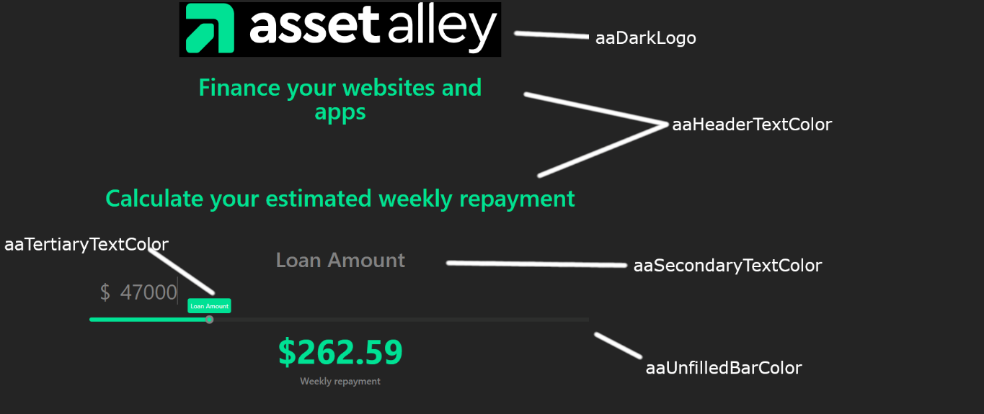

### Basic Implementation

This code will create the widget as an iframe where the script is placed.

|  |
| --- |
| //Create iframe <script type="text/javascript" src="http://assetalley.vercel.app/embed.js"></script> |

Implementation with Styling  
**To implement the landing page with custom styling, use the following code. To use your website’s colours, replace the colours below with appropriate hexadecimal values. See Page 5 – Variable List for more information**

|  |
| --- |
| <!--Style landing page  --> <script>          window.assetAlleyConfig = {              styles: {  //CSS Styles              },             aaReferral : 'YOUR_CODE',             aaCompact: 'true',  aaBusinessType: ‘website’             aaDarkLogo: 'true',            aaCustomLogo: 'false',             aaBackgroundColor: '#242424',             aaHeaderColor: '#01E194',             aaSecondaryTextColor: '#828282',             aaTertiaryTextColor: '#FFFFFF',             aaButtonColor: '#801f1f',             aaUnfilledBarColor: '#2E2E2E',             aaCalculatorWeekly: 'true',             aaCalculatorMonthly: 'true'          }      </script>  <!--Create iframe --> <script type="text/javascript" src="http://assetalley.vercel.app/embed.js"></script> |

Note: each field is optional and will use the default value if unspecified

**All variables are passed as strings**

**IMPORTANT: To be correctly associated with a client’s use of the website, aaReferral must be set using your referral code**

If you have already been provided with a referral link, your referral code follows the ‘**ref=’** in the referral link url.

EXAMPLE:

If your referral link is  
https://assetalley.vercel.app/?ref=12345

Then your referral code is **12345**

If you cannot find your referral code, please contact either:

Louie Dib [louie@assetalley.com.au](mailto:louie@assetalley.com.au) or  
Lachlan Rowley [lachlan@assetalley.com.au](mailto:lachlan@assetalley.com.au)

### Variable List

|  |  |  |
| --- | --- | --- |
| **Variable Name** | **Use** | **Default Value** |
| **aaReferral** | **Used by Asset Alley to track customer source**  **MUST BE SET TO BE ASSOCIATED WITH A REFERRAL** | **null** |
| aaCompact | Used to include an optional page about the benefits of financing through a loan (see below) | ‘false’ |
| aaDarkLogo | Used to control if Asset Alley’s logo text colour. Set as true if the logo will appear over a dark background | ‘true’ |
| aaCustomLogo | Used to control if Asset Alley’s logo will appear at the top of the landing page. Set to true if you want to use your company’s logo*  \***Requires manual implementation** | ‘false’ |
| aaBackgroundColor | Sets the landing page’s background colour | ‘#242424’ |
| aaHeaderColor | Sets the colour of titles and primary components’ fill | ‘#01E194’ |
| aaSecondaryTextColor | Sets the colour of non-title text that will appear directly on the background | ‘#828282’ |
| aaTertiaryTextColor | Sets the colour of text that will appear on coloured elements | ‘#FFFFFF’ |
| aaButtonColor | Sets the submit button colour | ‘#801F1F’ |
| aaUnfilledButtonColor | Sets the color of unfilled portion of the repayment slider and text input background | ‘#2E2E2E’ |
| aaCalculatorWeekly | Displays the calculated repayment in weekly amounts | ‘true’ |
| aaCalculatorMonthly | Displays the calculated repayment in monthly amounts.  Both repayment values can be show at the same time | ‘false’ |

### Optional Page

When aaCompact is false, this page is included before the requirements section



### FAQ

1. **The widget is too small**

The height of the widget is controlled by css styling.

Example solution

|  |
| --- |
| <script>  window.assetAlleyConfig = {  styles: {  height: ‘100vh’  },  … |

1. **How do I use my own logo?**

To use your own logo, set aaCustomLogo to ‘false’

You will need to insert your usual logo code above the widget <script>.

Example:

|  |
| --- |
| <div style="background-color:#242424; display: flex;   justify-content: center;  align-items: center; width: 100%;">          <img src="https://www.assetalley.com.au/wp-content/uploads/2024/05/icon.png" style="height: 10vh"/>  </div>  <script>  window.assetAlleyConfig = {  …  aaCustomLogo: ‘true’ }  </script> |